EX1: 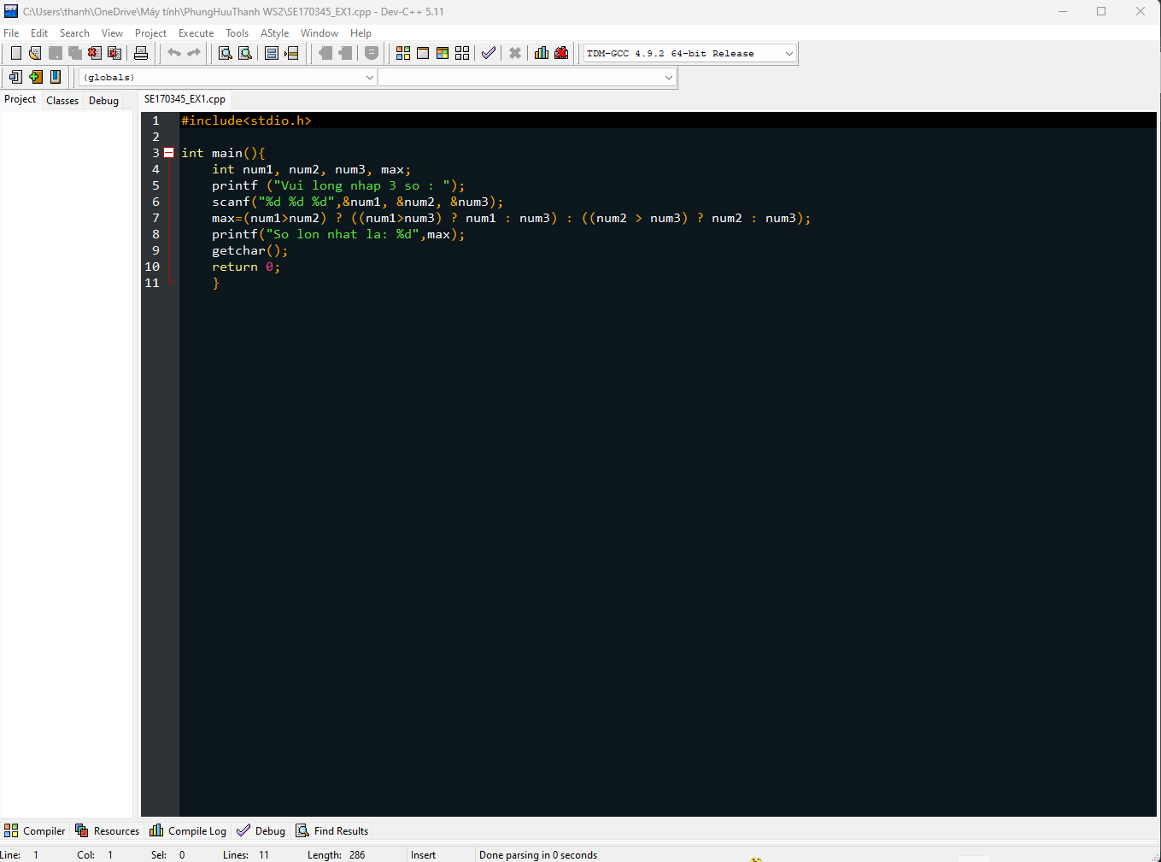

Ex 5:

Ex6:

Ex7:

